An excerpt from all quiet on the western front by erich maria remarque
A story from no man’s land
Then a new fear lays hold of me. I can no longer remember the direction. Quiet, I squat in a shell-hole and try to locate myself. More than once it has happened that some fellow has jumped joyfully into a trench, only then to discover that it was the wrong one.
After a little time I listen again, but still I am not sure. The confusion of shell-holes now seems so bewildering that I can no longer tell in my agitation which way I should go. Perhaps I am crawling parallel to the lines, and that might go on for ever. So I crawl round once again in a wide curve.
These damned rockets! They seem to burn for an hour, and a man cannot make the least movement without bringing the bullets whistling round.
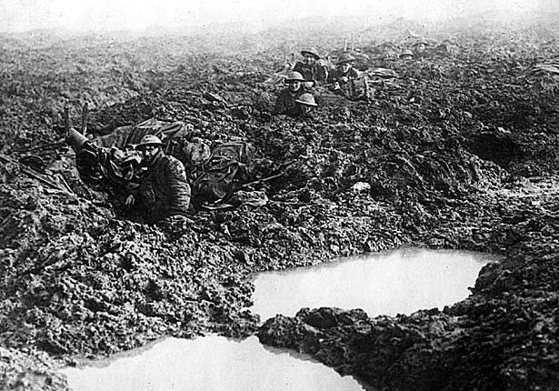
But there is nothing for it, I must get out. Falteringly I work my way farther, I move off over the ground like a crab and rip my hands sorely on the jagged splinters, as sharp as razor blades. Often I think that the sky is becoming lighter on the horizon, but it may be merely my imagination. Then gradually I realise that to crawl in the right direction is a matter of life or death.
A shell crashes. Almost immediately two others. And then it begins in earnest. A bombardment. Machine-guns rattle. Now there is nothing for it but to stay lying low. Apparently an attack is coming. Everywhere the rockets shoot up. Unceasing.
I lie huddled in a large shell-hole, my legs in the water up to the belly. When the attack starts I will let myself fall into the water, with my face as deep in the mud as I can keep it without suffocating. I must pretend to be dead.
Suddenly I hear the barrage lift. At once I slip down into the water, my helmet on the nape of my neck and my mouth just clear so that I can get a breath of air.
I lie motionless;--somewhere something clanks, it stamps and stumbles nearer--all my nerves become taut and icy. It clatters over me and away, the first wave has passed. I have but this one shattering thought: What will you do if someone jumps into your shell-hole?--Swiftly I pull out my little dagger, grasp it fast and bury it in my hand once again under the mud. If anyone jumps in here I will go for him. It hammers in my forehead; at once, stab him clean through the throat, so that he cannot call out; that's the only way; he will be just as frightened as I am; when in terror we fall upon one another, then I must be first.
Now our batteries are firing. A shell lands near me. That makes me savage with fury, all it needs now is to be killed by our own shells; I curse and grind my teeth in the mud; it is a raving frenzy; in the end all I can do is groan and pray.
The crash of the shells bursts in my ears. If our fellows make a counter-raid I will be saved. I press my head against the earth and listen to the muffled thunder, like the explosions of quarrying--and raise it again to listen for the sounds on top.
The machine-guns rattle. I know our barbed wire entanglements are strong and almost undamaged;--parts of them are charged with a powerful electric current. The rifle fire increases. They have not broken through; they have to retreat.
I sink down again, huddled, strained to the uttermost. The banging, the creeping, the clanging becomes audible. One single cry yelling amongst it all. They are raked with fire, the attack is repulsed.
Already it has become somewhat lighter. Steps hasten over me. The first. Gone. Again, another. The rattle of machine-guns becomes an unbroken chain. Just as I am about to turn round a little, something heavy stumbles, and with a crash a body falls over me into the shell-hole, slips down, and lies across me I do not think at all, I make no decision--I strike madly home, and feel only how the body suddenly convulses, then becomes limp, and collapses. When I recover myself, my hand is sticky and wet.
The man gurgles. It sounds to me as though he bellows, every gasping breath is like a cry, a thunder--but it is only my heart pounding. I want to stop his mouth, stuff it with earth, stab him again, he must be quiet, he is betraying me; now at last I regain control of myself, but have suddenly become so feeble that I cannot any more lift my hand against him.
So I crawl away to the farthest corner and stay there, my eyes glued on him, my hand grasping the knife--ready, if he stirs, to spring at him again. But he won't do so any more, I can hear that already in his gurgling.
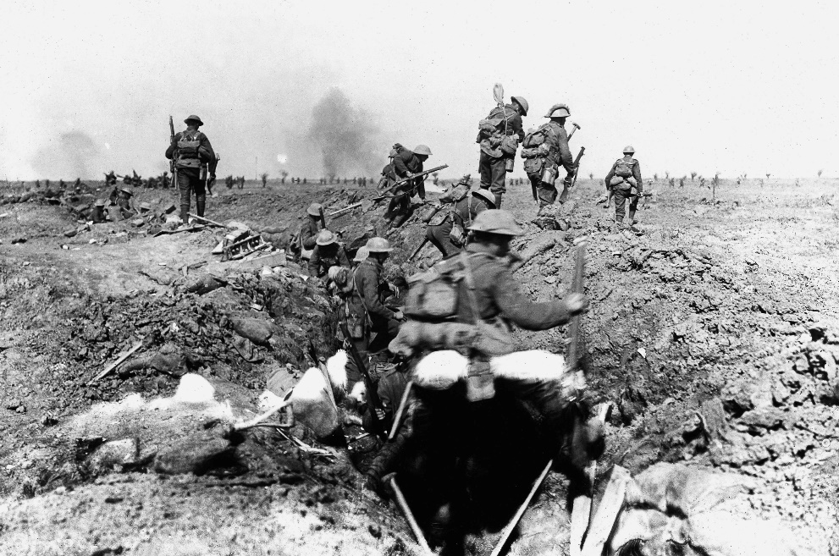
I can see him indistinctly. I have but one desire, to get away. If it is not soon it will be too light; it will be difficult enough now. Then as I try to raise up my head I see it is impossible already. The machine-gunfire so sweeps the ground that I should be shot through and through before I could make one jump.
I test it once with my helmet, which I take off and hold up to find out the level of the shots. The next moment it is knocked out of my hand by a bullet. The fire is sweeping very low to the ground. I am not far enough from the enemy line to escape being picked off by one of the snipers if I attempt to get away.
The light increases. Burning I wait for our attack. My hands are white at the knuckles, I clench them so tightly in my longing for the fire to cease so that my comrades may come.
Minute after minute trickles away. I dare not look again at the dark figure in the shell-hole. With an effort I look past it and wait, wait. The bullets hiss, they make a steel net, never ceasing, never ceasing.
Then I notice my bloody hand and suddenly feel nauseated. I take some earth and rub the skin with it; now my hand is muddy and the blood cannot be seen any more.
The fire does not diminish. It is equally heavy from both sides. Our fellows have probably given me up for lost long ago.
It is early morning, clear and grey. The gurgling continues, I stop my ears, but soon take my fingers away again, because then I cannot hear the other sound.
The figure opposite me moves. I shrink together and involuntarily look at it. Then my eyes remain glued to it. A man with a small pointed beard lies there; his head is fallen to one side, one arm is half-bent, his head rests helplessly upon it. The other hand lies on his chest, it is bloody.
He is dead, I say to myself, he must be dead, he doesn't feel anything any more; it is only the body that is gurgling there. Then the head tries to raise itself, for a moment the groaning becomes louder, his forehead sinks back upon his arm. The man is not dead, he is dying, but he is not dead. I drag myself toward him, hesitate, support myself on my hands, creep a bit farther, wait, again a terrible journey of three yards, a long, a terrible journey. At last I am beside him.
Then he opens his eyes. He must have heard me, for he gazes at me with a look of utter terror. The body lies still, but in the eyes there is such an extraordinary expression of fright that for a moment I think they have power enough to carry the body off with them. Hundreds of miles away with one bound. The body is still perfectly still, without a sound, the gurgle has ceased, but the eyes cry out, yell, all the life is gathered together in them for one tremendous effort to flee, gathered together there in a dreadful terror of death, of me.
My legs give way and I drop on my elbows. "No, no," I whisper.
The eyes follow me. I am powerless to move so long as they are there.
Then his hand slips slowly from his breast, only a little bit, it sinks just a few inches, but this movement breaks the power of the eyes. I bend forward, shake my head and whisper: "No, no, no," I raise one hand, I must show him that I want to help him, I stroke his forehead.
The eyes shrink back as the hand comes, then they lose their stare, the eyelids droop lower, the tension is past. I open his collar and place his head more comfortably.
His mouth stands half open, it tries to form words. The lips are dry. My water bottle is not there. I have not brought it with me. But there is water in the mud, down at the bottom of the crater. I climb down, take out my handkerchief, spread it out, push it under and scoop up the yellow water that strains through into the hollow of my hand.
He gulps it down. I fetch some more. Then I unbutton his tunic in order to bandage him if it is possible. In any case I must do it, so that if the fellows over there capture me they will see that I wanted to help him, and so will not shoot me. He tries to resist, but his hand is too feeble. The shirt is stuck and will not come away, it is buttoned at the back. So there is nothing for it but to cut it open.
I look for the knife and find it again. But when I begin to cut the shirt the eyes open once more and the cry is in them again and the demented expression, so that I must close them, press them shut and whisper: "I want to help you, Comrade, camerade, camerade, camerade--" eagerly repeating the word, to make him understand.
There are three stabs. My field dressing covers them, the blood runs out under it, I press it tighter; there; he groans. That is all I can do. Now we must wait, wait.
These hours.... The gurgling starts again--but how slowly a man dies! For this I know--he cannot be saved, I have, indeed, tried to tell myself that he will be, but at noon this pretence breaks down and melts before his groans. If only I had not lost my revolver crawling about, I would shoot him. Stab him I cannot.
By noon I am groping on the outer limits of reason. Hunger devours me, I could almost weep for something to eat, I cannot struggle against it. Again and again I fetch water for the dying man and drink some myself.
This is the first time I have killed with my hands, whom I can see close at hand, whose death is my doing. Kat and Kropp and Müller have experienced it already, when they have hit someone; it happens to many, in hand-to-hand fighting especially-- But every gasp lays my heart bare. This dying man has time with him, he has an invisible dagger with which he stabs me: Time and my thoughts.
I would give much if he would but stay alive. It is hard to lie here and to have to see and hear him. In the afternoon, about three, he is dead.

- What are some of the problems that soldiers faced in the trenches of World War 1
- What would you have done in the main character’s situation?
- How do you think soldiers passed the time in the trenches while they waited for battle?
- What do you think the most interesting part of this reading was? Why?

