NAME DATE CLASS

Visual Literacy Activity

The West Between the Wars

Analyzing Fascist Propaganda
Propaganda is a persuasive technique that presents a biased, or one-sided, message for or against a cause, group, or idea. The goal of propaganda is to appeal to people’s most basic emotions—love, hate, trust, loyalty, fear, prejudice, pride—in order to change or influence public opinion. Propaganda often uses simple words and powerful images to repeat messages and distort, conceal, or fabricate facts and information. A powerful tool of propaganda is censorship, which allows only the “official” stance to be transmitted and suppresses all other viewpoints. When you learn how to identify and interpret the various elements of propaganda, you will know how to recognize one-sided messages that are intended to manipulate your emotions and shape your point of view.
Directions: The Fascist propaganda poster below shows Italian leader Benito Mussolini. Look closely at the poster, analyze it, and answer the questions that follow.
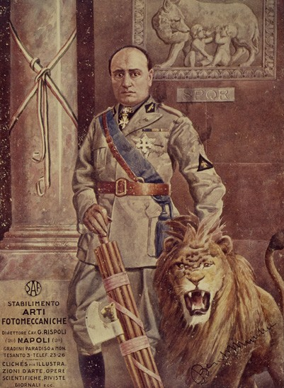
akg-images
Benito Mussolini, Leader of Fascism, artist unknown, 1930.

Background
Benito Mussolini (1883–1945) was the first Fascist dictator who came to power during the “interwar” years of the early twentieth century. Like other totalitarian dictators, he realized the power of modern communications to spread propaganda. As soon as he declared his dictatorship in 1925, he immediately put his Fascist Party in charge of the media, law enforcement, industry, and education as part of his goal to establish complete control over the Italian people. Professional communicators—newspaper and magazine writers and editors, filmmakers, graphic artists, radio programmers, speechwriters—no longer had the freedom to shape their own messages. The Fascist Party dictated what could be communicated in the media.

NAME DATE CLASS
In Fascist Italy, media propaganda was used to spread specific messages about the Fascist government’s policies and initiatives, but one of its main uses was simply to create, transmit, and maintain Mussolini’s image as the supreme leader of his nation. Like other totalitarian dictators, Mussolini and his Fascist Party cultivated a cult leader, a great and charismatic ruler whom the Italian people would be encouraged to “worship.” This dictator would not only save his people from their enemies but also carve an aspirational vision of the nation’s future. This image of Mussolini as Il Duce (“The Leader”) was a large part of Italian Fascist propaganda. In addition to visual media such as posters and documentary films, one of the most effective means of transmitting propaganda was the radio, which could broadcast Il Duce’s distinctive voice into the most isolated homes, making even illiterate people feel connected to their nation’s all-powerful leader.

The poster of Mussolini shows Il Duce holding the fasces, a bundle of rods tied together with an axe. The Fascists adopted the fasces, a symbol of imperial authority in ancient Rome, as their symbol. (The word Fascist comes from the English word fasces as well as from the Italian word fascio, which means “group.”) On the wall behind Mussolini is an image of the mythological founders of Rome, Romulus and Remus—twins who were suckled by a wolf. Also, Mussolini stands next to and controls a lion, a commonly recognized symbol of strength, authority, and courage. Since the Italian Fascists sought to recapture some of Italy’s former greatness, their propaganda repeatedly referenced power and the glories of the ancient Roman Empire.

Practicing the Skill
- Interpreting What is the significance of the engraving of Romulus and Remus in the background and the fasces in the foreground? What other symbols do you notice? What did the creators of this poster want the Italian people to think about Mussolini?
NAME DATE CLASS
- Analyzing Review the key tools of propaganda mentioned in the first paragraph. Which of these tools did the creators of this poster use?

Go a Step Further
- Explaining What might be some advantages of presenting propaganda in a visual form, such as posters and film? What media today might be most effective in spreading propaganda to the greatest number of people?

