NAME DATE CLASS

Visual Literacy Activity

World War II and the Holocaust

Analyzing Historical Photographs: The Battle of Stalingrad
World War II was the most devastating war in history, but the Battle of Stalingrad (July 17, 1942–February 2, 1943) stands out as one of its most terrible confrontations. The hardships of the Russian winter combined with the Red Army’s surprising tenacity and Adolf Hitler’s poor decisions led to a catastrophic defeat for the German army. It marked a moment at which the war finally turned in the Allies’ favor. Photographs might allow you to better visualize these hardships or to relate to events in ways that words might not.
Directions: The two photographs document conditions experienced by both the Soviet and the German armies during the Battle of Stalingrad during World War II. Look closely at the two photographs, analyze them, and answer the questions that follow.
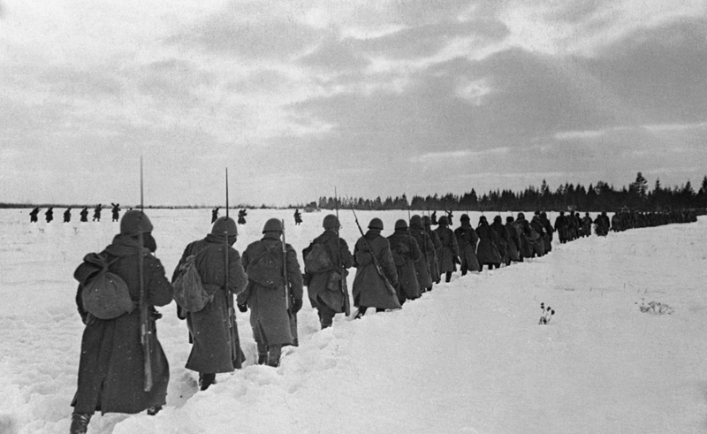
© Bettmann/CORBIS

Russian troops marching through snow in the Stalingrad area.

Background
Hitler was confident that the Battle of Stalingrad, which began in the summer of 1942, would be over long before the treacherous Russian winter set in. He believed in his armies and did not take into account the unpredictability of Russian weather or dedication of the Soviet army. Despite the harsh winter, the Soviet army refused to give up the defense of its burned cities and caused the brutal, hand-to-hand fighting of the war to drag on into winter. The German troops were not equipped with winter clothing. Sub-zero temperatures, icy conditions, high winds, and lack of visibility from snowstorms often made the use of aircraft, tanks, and even machine guns impossible.
On November 19 and 20, 1942, the Red Army managed to completely surround the German troops outside Stalingrad and cut off their supply lines. German soldiers began to starve; to survive, they ate their horses. Many lived in trenches and dugouts,

NAME DATE CLASS
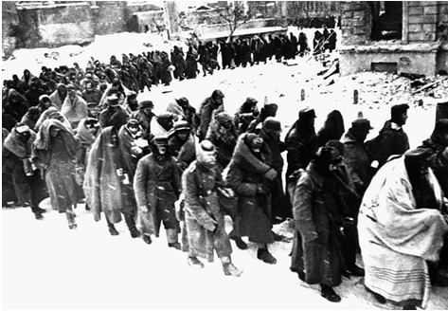
© CORBIS
German prisoners of war in Russia struggling to survive the cold.
exposed to sub-zero temperatures and typhus spread by lice-carrying mice. Their bodies were often found frozen in the positions they had been in at the moment of death. Yet the weather was no less deadly for Soviet troops. As they surrounded the Germans, some of the Red Army troops had not yet received their winter uniforms, gloves, hats, or foot wraps. Both horses and soldiers froze to death.
In spite of the urgings of the German high command and the advice of General Paulus, leader of the Sixth Army, Hitler would not allow his armies to retreat or surrender. Finally, on January 31, 1943, General Paulus and 24 other German generals disregarded Hitler and surrendered to the Soviets. Out of over 330,000 soldiers, only about 91,000 survivors—starving, frostbitten, and ill—remained to be taken as prisoners of war. The Russian soldiers, warm in their gloves, boots, and coats, were not inclined to compassion. Many of the German POWs had high fevers from typhus; the soldiers had never been inoculated against the disease. Ultimately, about 50,000 German prisoners of war died from typhus. Most of the others died in labor camps. Only 5,000 survivors of the Sixth Army survived to return to Germany.

Practicing the Skill
- Analyzing Based on the photograph of the Soviet soldiers walking through the snow, what advantages did they have over the German soldiers?
NAME DATE CLASS
- Making Inferences Look at the photograph of the German prisoners of war. In addition to the cold, what other hardships did these prisoners of war face?
- Drawing Conclusions What defeated the Germans: the harsh Russian winter, the skill and dedication of the Soviet Red army, or Hitler’s incorrect assumptions and decisions? Support your answer with evidence.

Go a Step Further
- Speculating The Germans lost almost 300,000 soldiers in the Battle of Stalingrad. The Soviets lost over a million Red Army members and at least 40,000 city inhabitants. Although the German army had massive casualties and lost the battle, Soviet loss of life was even greater. Can a nation sustain such losses and still be considered victorious? Explain.

