RUSSIAN REVOLUTION OF 1905
BLOODY SUNDAY DOCUMENTS

Document 1 - The demands made by Georgy Gapon and the Assembly of Factory Workers
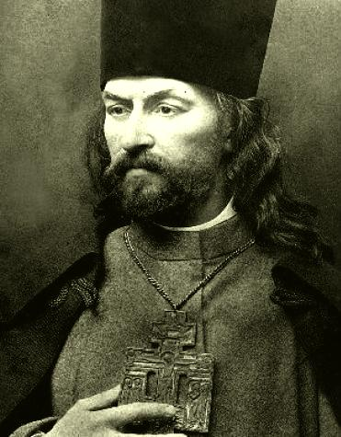
On January 22, 1905, the day after a general strike burst out in St. Petersburg, Father Georgy Gapon organized a workers' procession to present an emotionally charged written petition to Czar Nicholas II.

1. An 8-hour day and freedom to organize trade unions.
2. Improved working conditions, free medical aid, higher wages for women workers.
3. Elections to be held for a constituent assembly by universal, equal, and secret suffrage.
4. Freedom of speech, press, association, and religion.
5. An end to the war with Japan.

- Based on the demands made by Georgy Gapon, what was life like in Russia in 1905?
FATHER GEORGY GAPON
1870-1906

- Which of these demands is the most realistic? Unrealistic? Explain your answers.

Document 2 – Georgy Gapon, The Story of My Life (1905) recalling events

The procession moved in a compact mass. In front of me were my two bodyguards and a yellow fellow with dark eyes from whose face his hard laboring life had not wiped away the light of youthful gaiety. On the flanks of the crowd ran the children. Some of the women insisted on walking in the first rows, in order, as they said, to protect me with their bodies, and force had to be used to remove them.

Suddenly the company of Cossacks [soldiers] galloped rapidly towards us with drawn swords. So, then, it was to be a massacre after all. There was no time for consideration, for making plans, or giving orders. A cry of alarm arose as the Cossacks came down upon us. Our front ranks broke before them, opening to right and left, and down the lane the soldiers drove their horses, striking on both sides. I saw the swords lifted and falling, the men, women and children dropping to the earth like logs of wood, while moans, curses and shouts filled the air.

Again we started forward, with solemn resolution and rising rage in our hearts. The Cossacks turned their horses and began to cut their way through the crowd from the rear. They passed through the whole column and galloped back towards the Narva Gate, where – the infantry having opened their ranks and let them through – they again formed lines.

We were not more than thirty yards from the soldiers, being separated from them only by the bridge over the Tarakanovskii Canal, which here marks the border of the city, when suddenly, without any warning and without a moment’s delay, was heard the dry crack of many rifle-shots. Vasiliev, with whom I was walking hand in hand, suddenly left hold of my arm and sank upon the snow. One of the workmen who carried the banners fell also, immediately one of the two police officers shouted out “What are you doing? How dare you fire upon the portrait of the Czar?”

An old man named Lavrentiev, who was carrying the Czar’s portrait, had been one of the first victims. Another old man caught the portrait as it fell from his hands and carried it till he too was killed by the next volley. With his last gasp the old man said “I may die, but I will see the Czar.”

Both the blacksmiths who had guarded me were killed, as well as all these who were carrying the icons and banners; and all these emblems now lay scattered on the snow. The soldiers were actually shooting into the courtyards at the adjoining houses, where the crowd tried to find refuge and, as I learned afterwards, bullets even struck persons inside, through the windows.

At last the firing ceased, I stood up with a few others who remained uninjured and looked down at the bodies that lay prostrate around me. Horror crept into my heart. The thought flashed through my mind. And this is the work of our Little Father, the Czar.” Perhaps the anger saved me, for now I knew in very truth that a new chapter was opened in the book of history of our people.

- According the Georgy Gapon, what happened when the soldiers met the crowd?

- Why might this event, known as Bloody Sunday, be one of the major causes of the Russian Revolution of 1905?

Document 3 – Czar Nicholas II diary entry – January 21, 1905

There was much activity and many reports. Fredericks came to lunch. Went for a long walk. Since yesterday all the factories and workshops in St. Petersburg have been on strike. Troops have been brought in from the surroundings to strengthen the garrison. The workers have conducted themselves calmly hitherto. Their number is estimated at 120,000. At the head of the workers’ union, some priest – socialist Gapon. Mirsky came in the evening with a report of the measures taken.

- According to the diary entry of Czar Nicholas II, how did the Czar view Father Gapon?

- Based on the previous documents, why might the Czar make this claim?

Document 4 – Czar Nicholas II diary entry – January 22, 1905

A painful day. There have been serious disorders in St. Petersburg because workmen wanted to come up to the Winter Palace. Troops had to open first in several places in the city; there were many killed and wounded. God, how painful and sad.

- According to the diary entry of Czar Nicholas II, how did he feel about the events of Bloody Sunday?

- Do you believe he truly felt that way? Why or why not?

