NAME DATE CLASS

Geography and History Activity

World War II and the Holocaust

D-Day: The Normandy Invasion
By 1943, Allied leaders realized that they would need to open a second front in western Europe if they wanted to break Hitler’s power on the European continent. They developed a plan to invade Normandy, the northern region of France, under the direction of U.S. general Dwight D. Eisenhower. The Allies knew that Hitler suspected an invasion, so they would need careful development and preparation to be successful. In the months leading up to D-Day, British and U.S. air forces began bombing French railroads and bridges. Allied intelligence officers also planted false information to confuse the Germans about the true location of the invasion, including that the assault would take place at Calais.
The invasion finally took place on June 6, 1944. Led by both U.S. and British commanders, more than 156,000 Allied troops landed on the beaches of Normandy. Five infantry divisions crossed the English Channel in armored vessels, each landing on a different beach—codenamed Utah, Omaha, Gold, Juno, and Sword. Meanwhile, three airborne divisions landed to the east and west of the assault area.
Although they caught the German forces largely off-guard, the Allies had to overcome serious obstacles before they could advance. Bad weather had made the waters of the English Channel rough and dangerous; hundreds of vessels sank and many soldiers drowned before they could even reach the shore. In addition, the Germans had fortified the coast with mines, barbed wire, and defensive walls, which slowed the Allies’ progress. Perhaps most deadly of all, the Germans had heavy artillery and machine guns positioned on the cliffs that overlooked the coast; thousands of Allied troops were shot before they were able to cross the exposed beaches. Although the landing was successful, by the end of D-Day, more than 10,000 Allied troops had been killed, wounded, or were missing.
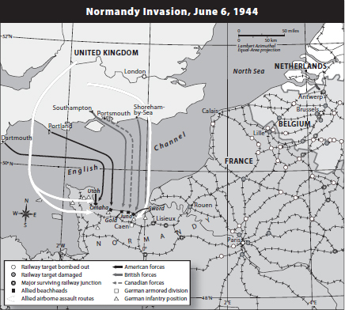
On June 6, 1944, Allied forces opened a second front in the European Theater by landing on the beaches of Normandy in northern France.
1

NAME DATE CLASS

Understanding Concepts
1. Location British intelligence agents planted false information to convince the Germans that the Allied invasion would take place at Calais. Look at the map. Why did the location of Calais make the possibility of invasion there believable?
2. Human-Environment Interaction The Allied forces faced many obstacles during the invasion of Normandy, many of which were due to the coastal location chosen for the invasion. Other obstacles were created by the Germans. Complete the following diagram to outline these obstacles and how they affected the Allied forces on D-Day.
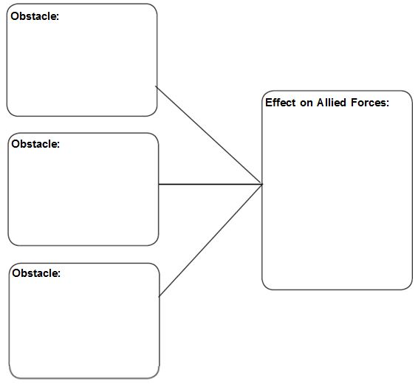
2

NAME DATE CLASS

Applying Concepts
3. Drawing Conclusions What advantages would the Allies gain by utilizing both airborne and seaborne divisions during the invasion? How was this dual strategy possible?
4. Analyzing Information On the map, small circles represent areas where railways had been damaged or destroyed. Where was the most damage done to the railways? Why was bombing railways an important part of the Allies’ strategy?
5. Making Connections Why is the Normandy invasion considered one of the turning points of World War II?
3

