NAME DATE CLASS

Geography and History Activity

The West Between the Wars

Lebensraum as Expansion
Closely related to political geography—states’ relations with one another and with the relationships between citizens and governments—is geopolitics, or the analysis of how geography influences international relations. Geopolitics is pertinent when considering the German plan for obtaining Lebensraum, or “living space,” to accommodate the planned expansion of the German empire and the “master race.” Another concept relevant to Lebensraum is the idea of environmental determinism, which says that features of the environment have a direct effect on aspects of human behavior and society.
The idea of Lebensraum originated with Friedrich Ratzel, a German geographer who said the state was like a biological organism and pointed out that a state’s boundaries can expand or contract due to “rational capabilities.” The Nazis later misused this concept as they sought to justify their attempted expansion into the landlocked area of central Eurasia shown in the map below. British political geographer Sir Halford J. Mackinder saw this area, called the heartland or the Pivot Area, as the key to world domination. In the early twentieth century, Mackinder argued that this area had strategic importance as the “World Island” due to the declining importance of sea power as compared to land power. Mackinder saw the role of Britain and the United States as preserving a balance of power between the countries vying for control of the heartland.
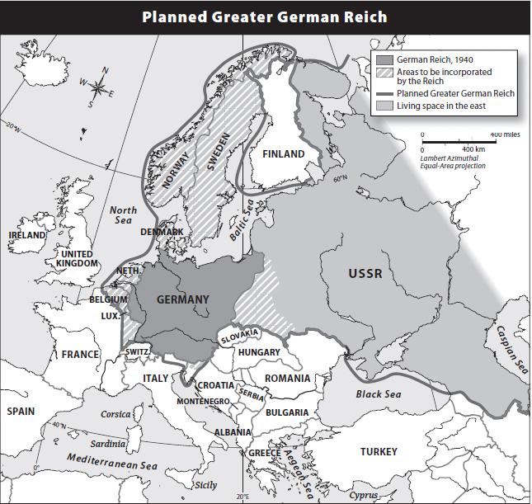
Caption: The Nazi plan to obtain Lebensraum
affected the German heartland and its periphery.
1

NAME DATE CLASS
Ratzel’s and Mackinder’s ideas were taken up by German geopolitician Karl Haushofer, who advocated German control of the heartland and its periphery, or outward boundaries. Haushofer also was influenced by the ideas of Rudolf Kjellen, a Swedish political scientist who saw the state as a real organism that had a natural right to grow.
Directions: Answer the questions below in the space provided.

Understanding Concepts
- Interpreting According to the map, in which directions did the Nazis plan to expand their living space? Describe Germany’s projected periphery.
- Explaining Explain how geopolitics influenced the origin and development of the Nazi idea of Lebensraum.

Applying the Concept
- Comparing and Contrasting Complete the following graphic organizer to show which areas of Europe that Germany planned to occupy.
Country | Did Germany plan to occupy it?
Italy | No
France
Spain
Portugal
Norway
Sweden
Finland
Poland
Greece
Turkey
Russia
Switzerland
Denmark
2
NAME DATE CLASS
- Drawing Conclusions Why might control of the heartland be less important today than it was in World War II?
- Making Connections How is the concept of Lebensraum linked to environmental determinism?
3

