NAME DATE CLASS

Geography and History Activity

World War II and the Holocaust

German Expansion: Hitler’s Quest for Cultural Domination
Hitler’s plans for German expansion were rooted in his dream to make German culture the dominant way of life in Europe—and around the world. Hitler believed that to achieve this cultural diffusion, Germany had to acquire more land to provide lebensraum, or “living space,” for the German people. In order to make room for German settlers, Hitler also planned to remove people that he believed to be inferior—such as Jews, Roma, and Slavs—by killing them or by sending them to labor camps.
The geopolitical concept of lebensraum originated with the German geographer Friedrich Ratzel. In the late nineteenth century, Ratzel developed the theory that the development of all species, including humans, was determined by their adaptation to geographic circumstances. At the time, this theory was used to support the creation of a united Germany in which increasing the country’s strength meant encouraging migration to German colonies. However, Hitler and the Nazi Party later seized upon Ratzel’s ideas to support German territorial expansion within Europe.
Hitler’s first step was to reunite all German-speaking peoples, such as those in Austria and Czechoslovakia, under the Third Reich. In September 1939, Hitler initiated the next step of his plan to extend German control by invading Poland. As German forces moved through Europe, they systematically executed or evacuated millions of people to make room for resettlement by German peasants.
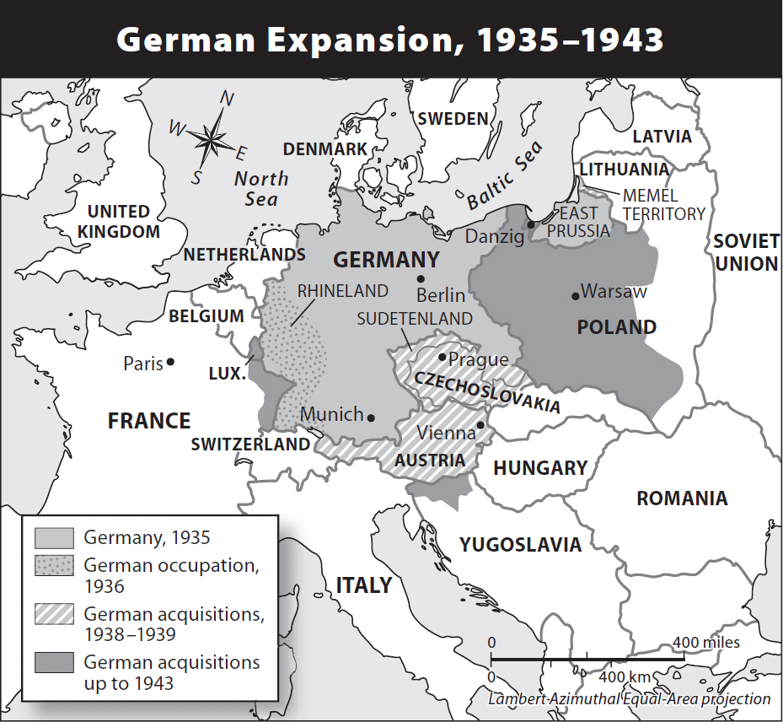
The first step in Hitler’s plans for German expansion was to bring German-speaking people in Austria and Czechoslovakia under the rule of the Third Reich. Germany began its program of expansion and resettlement with the invasion of Poland in 1939.
1
NAME DATE CLASS
Directions: Answer the questions below in the space provided.

Understanding Concepts
1. Movement Into which parts of Europe did Germany first expand? Why?
2. Describing How did Hitler plan to achieve the diffusion of German culture throughout Europe?
3. Analyzing Information What does the map suggest about the success of German expansion between 1933 and 1943?

Applying Concepts
4. Making Inferences What would the map of Europe look like according to Hitler’s goals?
2
NAME DATE CLASS
5. Making Connections Complete the following chart to describe how Hitler’s plan for German expansion changed the face of Europe.
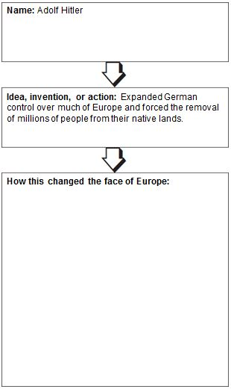
3

