NAME DATE CLASS

Geography and History Activity

World War II and the Holocaust

Japanese Expansion Before World War II
Resources are the available means by which a country can develop economically and politically. Access to natural resources—including minerals, soil, fossil fuels, and fresh water—is critical to a country’s economic growth, especially to the expansion of industrialization.
In the 1930s, Japan’s economy was becoming increasingly industrialized and the Japanese population was booming. However, as a small island nation, Japan’s access to natural resources was too limited to sustain this growth. Japan’s mountainous terrain, characterized by poor soil, rugged mountains, and swift-flowing rivers, was not suited for agriculture, and the amount of land that could be used to cultivate food for the growing population was limited. In addition, Japan lacked the natural deposits of minerals and fossil fuels that were necessary to support an industrial economy.
The Japanese believed that the solution to their economic problems was to use military force to gain control of lands that were rich in resources. Through a series of military conquests, they gained economic and political control over territories that were rich in natural resources. Coal is abundant in Northeast and North Central China; Northeast China is also rich in petroleum. Fertile soil is found in the floodplain of the Yangtze River. By 1941, the Japanese had expanded throughout much of East and Southeast Asia.
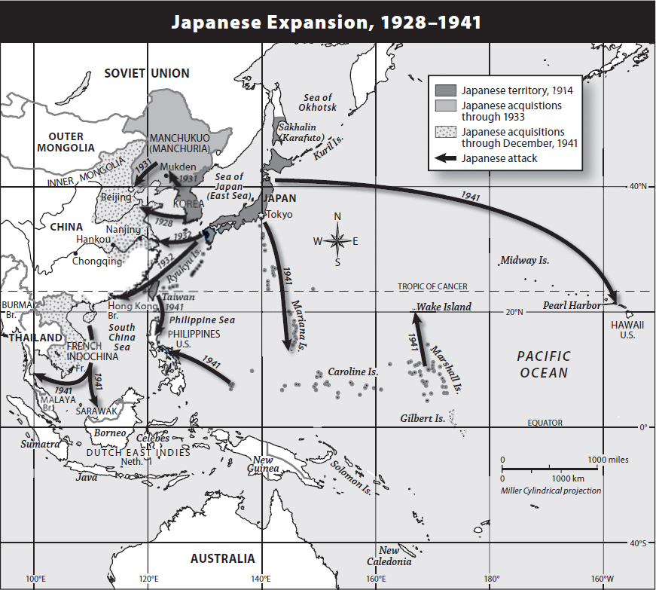
After World War I ended, Japan used military force to expand its national territory into Manchuria, China, and Southeast Asia.
1

NAME DATE CLASS
Directions: Answer the questions below in the space provided.

Understanding Concepts
1. Location Look at the map. What territories did Japan control in 1914? Why would having control of territory on the mainland be useful to the Japanese military in the 1930s?
2. Time, Chronology, and Sequencing The Japanese expanded their territory on the mainland over the course of more than 20 years. Complete the timeline below to summarize the progress of Japanese expansion from 1914 to 1941.
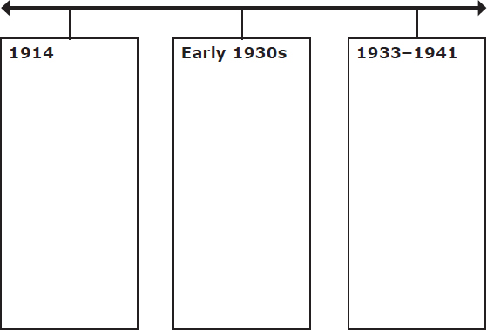
3. Drawing Conclusions What are natural resources? Why did the Japanese want access to additional natural resources? What does this indicate about Japanese political and economic goals in the 1930s?
2

NAME DATE CLASS

Applying Concepts
4. Movement Throughout the map, arrows are used to show the progress of the Japanese military as it invaded neighboring Asian countries. What does the direction of expansion suggest about Japan?
5. Making Connections Why did the Japanese risk more serious consequences by invading Southeast Asia than they did by invading Manchuria and north China?
3

