NAME DATE CLASS

Primary and Secondary Sources
Activity

The West Between the Wars

The Message of Nazism

Background
To communicate the message of Nazism, Adolf Hitler used powerful visual symbols displayed prominently at rallies, demonstrations, and mass meetings. The most potent symbol—the swastika—has been adopted by many cultures throughout history as a symbol of good luck, peace, or prosperity. In the early 1900s it became associated with right-wing groups in Germany, which held extreme nationalistic and anti-Semitic views.
Hitler believed his Third Reich was the natural successor to the First Reich (the early Holy Roman Empire) and the Second Reich (the German Empire from 1871 to 1918). The Nazi Party flag paid homage to the past by borrowing the colors of the imperial flag of the Second Reich. As an imperial emblem, the eagle first appeared in the German kingdoms that comprised the First Reich. It adorned the flags of the Holy Roman Empire and later the Second Reich. The Nazis displayed the eagle on badges, on medallions, on stationery, and, most notably, atop monuments and parade standards.
The city of Nuremberg also became a symbol for the Nazi Party. During the late Middle Ages, Nuremberg grew from a fortified German settlement into a thriving center of German culture and learning. Because of its historical significance, Hitler chose Nuremberg for the site of the massive party rallies that eventually became annual events.
Directions: Read the selection and study the poster and its callouts. Then answer the questions. Use prior knowledge and information from your text to provide some answers.
After innumerable trials I decided upon a final form—a flag of red material with a white disc bearing in its centre a black swastika. After many trials I obtained the correct proportions between the dimensions of the flag and of the white central disc, as well as that of the swastika. And this is how it has remained ever since . . .
The new flag appeared in public in the midsummer of 1920. It suited our movement admirably, both being new and young. Not a soul had seen this flag before; its effect at that time was something akin to that of a blazing torch. We ourselves experienced almost a boyish delight when one of the ladies of the party who had been entrusted with the making of the flag finally handed it over to us. And a few months later those of us in Munich were in possession of six of these flags. The steadily increasing strength of our hall guards was a main factor in popularizing the symbol.
And indeed a symbol it proved to be.

continued on next page

NAME DATE CLASS
continued from previous page
Not only because it incorporated those revered colours expressive of our homage to the glorious past and which once brought so much honour to the German nation, but this symbol was also an eloquent expression of the will behind the movement. We National Socialists regarded our flag as being the embodiment of our party programme. The red expressed the social thought underlying the movement. White the national thought. And the swastika signified the mission allotted to us—the struggle for the victory of Aryan mankind and at the same time the triumph of the ideal of creative work which is in itself and always will be anti-Semitic.
—Adolf Hitler, from Mein Kampf, 1925
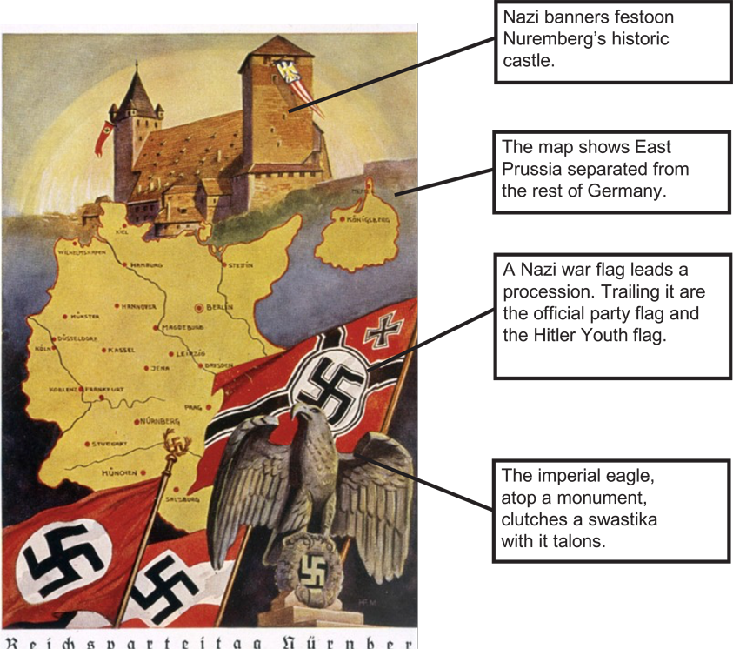
Mary Evans Picture Library/The Image Works

Caption: Nazi propaganda poster from
Nuremberg Rally, 1934.

NAME DATE CLASS
- Analyzing Primary and Secondary Sources Describe the Nazi flag and explain what the elements on it symbolize. To what was Hitler referring when he mentioned “those revered colours expressive of our homage to the glorious past”? Why did he revere this past?
- Analyzing Information According to the excerpt, why did Hitler believe the swastika embodied anti-Semitism?
- Making Connections What sentiments would the image of the banner-festooned Nuremberg castle inspire in the minds of Germans? Why would the map of Germany provoke bitter memories for Germans?
- Identifying Central Issues What message might the Nazis have wanted to communicate by including several different Nazi flags on the poster? What message is conveyed by showing the eagle clutching a swastika with its talons?
- Synthesizing Explain why the propaganda techniques described above would have been effective in gaining the allegiance of the German people. What other factors helped Hitler and the Nazi Party seize power in Germany?

