NAME DATE CLASS

Visual Literacy Activity

World War II and the Holocaust

Analyzing a Political Cartoon
Political cartoons sometimes seem to forecast the future by suggesting current looming dangers or concealed motivations. Although presented humorously or satirically, these visual commentaries often have an unsettling truth at their core: a truth that many in the audience may already suspect. When you analyze political cartoons, observe the details that are directly presented, but also think about what is implied, or suggested. What message is the cartoonist trying to send? What methods—exaggeration, satire, figurative comparisons, ridicule, irony—does he or she use to create that message?
Directions: The political cartoon depicts one cartoonist’s ideas about the Nazi-Soviet Nonaggression Pact. Look closely at the cartoon, analyze it, and answer the questions that follow.
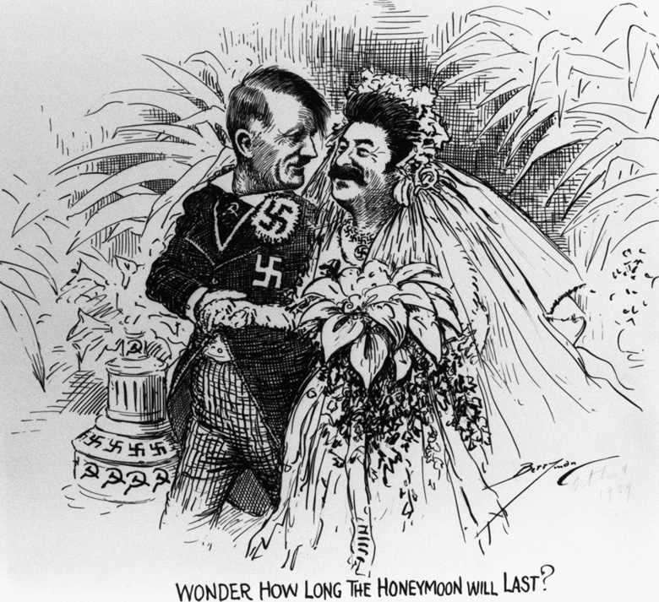
CORBIS

Wonder How Long the Honeymoon Will Last?, Clifford Kennedy Berryman, c. 1939.

NAME DATE CLASS

Background
The Nazi-Soviet Nonaggression Pact was signed enacted by Germany and the Soviet Union on August 23, 1939. On the surface, the pact was a 10-year peace treaty in which the two nations promised not to attack—or support any enemy powers in attacking—each other. What the rest of the world did not know, but perhaps suspected, was that there was more to the pact than what was seen on the surface. In order for each side to get what it really wanted from the treaty, the Germans and Soviets had reached an “under the table” agreement, a secret provision that allowed the two powers to split eastern Europe into spheres of influence: specific territories over which they would hold political sway and exercise their national interest. Eastern Poland and several other countries fell under the Soviet Union’s sphere of influence; western Poland was left to Germany. Hitler wasted no time; on September 1, his forces, unopposed by the Soviet Union, invaded western Poland, officially beginning World War II.
It is doubtful that Hitler and Stalin ever truly trusted each other. The two leaders were each obsessed with their own self-interest and goals for domination. According to a high-ranking Soviet leader, Stalin was convinced that the pact would enable him to manipulate or completely control Hitler. For his part, Hitler had always viewed the treaty as a convenient tactic that served his needs. On May 5, 1941, Stalin publicly threatened a future war against Germany, and on June 22, 1941, Hitler began Operation Barbarossa, the German invasion of the Soviet Union that had as its goal nothing less than the total destruction of Stalin’s Communist state.
The 1939 political cartoon Wonder How Long the Honeymoon Will Last? suggests the underlying deception of the Nonaggression Pact in its depiction of a marriage scene of Adolf Hitler and Joseph Stalin. Clifford Kennedy Berryman (1869–1949), who was born in Kentucky, was a Pulitzer Prize–winning cartoonist who worked for the Washington Post from about 1889 to 1907 and for the Washington Evening Star from 1907 until his death in 1949. Wonder How Long the Honeymoon Will Last? was probably printed in the Evening Star on October 9, 1939.

Practicing the Skill
Interpreting What does Berryman’s portrayal of Hitler and Stalin tell you about how he viewed these two figures?

NAME DATE CLASS
Drawing Conclusions What is a honeymoon phase? How does the title of the cartoon apply to the Nonaggression Pact?
Predicting Consequences Based on what you know about how the Nazi-Soviet Nonaggression Pact ended, in what ways is this cartoon prophetic, or predictive of the future?

Go a Step Further
Synthesizing Over the years political cartoonists have often satirized world leaders, making them targets of ridicule. What do you think cartoonists achieve by mocking such figures?

