NAME DATE CLASS

Primary and Secondary Sources
Activity

World War I and the Russian Revolution

Russia after World War I

Background
When Russia got out of World War I in 1918—after the signing of the Treaty of Brest- Litovsk—conditions in Russia were far from peaceful. The civil war that followed was fought on many fronts throughout the country. The Red (Communist) Army fought against the White (anti-Communist) Army until most of the White Forces were defeated. The fall of the monarchy and the execution of the royal family in 1918 ushered in an era of terror that resulted in the Communist takeover of the country by 1921.
Directions: Study the propaganda poster and the excerpt. Then answer the questions.
continued on next page
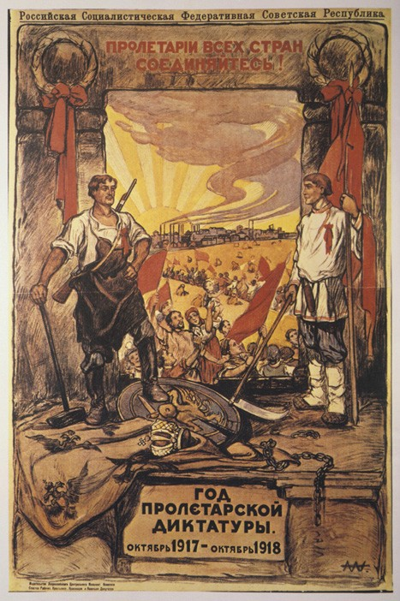
Snark/Art Resource, NY
Year of the Proletarian Dictatorship,
Aleksandr Apsit, 1918.

NAME DATE CLASS
continued from previous page
Communism is Soviet power plus the electrification of the whole country. Otherwise the country will remain a small-peasant country, and that we must clearly realize. We are weaker than capitalism, not only on the world scale but also within the country. Everybody knows that. We have realized it, and we shall see to it that the economic basis is transformed from a small- peasant basis into a large-scale industrial basis. Only when the country has been electrified, when industry, agriculture and transport have been placed on the technical basis of modern large-scale industry, only then shall we be finally victorious.
—V. I. Lenin, remarks to the Congress of Soviets, 1920
Paraphrasing Use your own words to summarize Lenin’s remarks.
Analyzing Visuals The propaganda poster Year of the Proletarian Dictatorship was created by the Russian artist Aleksandr Apsit. It illustrates some of the goals of the Communists after the Russian Revolution. Based on the poster, what were two major goals of the Communists at this time?
Analyzing Examine the images on the poster and explain why the poster works as propaganda.

NAME DATE CLASS
Drawing Conclusions Why do you think a Communist revolution occurred in Russia rather than in an industrialized nation?
Inferring The literacy level of the Russian population right after World War I was very low. Explain why propaganda posters such as the one shown here were effective methods of reaching the peasant population.

