NAME DATE CLASS

Primary and Secondary Sources Activity

World War II and the Holocaust

Ending the War: The Bombings of Hiroshima and Nagasaki

Background
In 1938 scientists discovered that an enormous amount of energy could be released by splitting an atom. Realizing this knowledge could be used to create a devastating weapon, they alerted U.S. president Roosevelt to the potential military applications of their discovery. In 1942 the U.S. government, fearing that the Germans might make an atomic bomb, launched a top-secret project to develop one first. Code-named the Manhattan Project, it cost $2 billion and employed 600,000 people. On July 16, 1945, an atomic bomb was successfully tested near Alamogordo, New Mexico.
Less than a month later—on August 6, 1945—the first nuclear weapon was dropped on Hiroshima, Japan, a military center. The count of those killed during the blast or shortly afterward has been estimated to as many as 70,000, with 140,000 dead at year’s end from injuries and radiation sickness. This atomic bomb annihilated two-thirds of the city. Three days later, on August 6, the United States released another atomic bomb, this time over the Japanese port city of Nagasaki. By December 1945, 70,000 citizens were dead. The blast damaged or demolished 40 percent of the city’s buildings. The incredible destruction caused by the bombing of Hiroshima and Nagasaki forced the surrender of Japan, ending World War II.
Directions: The first selection is from an interview with Colonel Paul Tibbets, the pilot of the plane that bombed Hiroshima. The second one is from an account in which Shibayama Hiroshi, a survivor of the bombing, describes what he saw when he crossed the Kyobashi River hours after the bomb was dropped. The photograph shows Hiroshima after the bombing. Read the selections and study the photograph. Then answer the questions.
I looked at that city—and there was no city, there was nothing but the fringes of where the city used to be. There had been a city when we were making our approach, but now there was no humanity there. It was just something that had been . . . scorched. That word doesn’t seem sufficient to describe what had just happened, but that’s the only word I have. I could never have imagined anything being scorched like that city was scorched . . .
Our crew did not do the bombing in anger. We did it because we were determined to stop the killing. I would have done anything to get to Japan and stop the killing.
—Colonel Paul Tibbets, 1945 as quoted in Duty: A Father, His Son,
and the Man Who Won the War

NAME DATE CLASS
Floating there were scores of dead bodies, faces swollen to twice their normal size and trouser-encased legs stiff as logs. . . . The sight chilled us to the bone . . . It began to rain. Black stains spotted shirts. The multicolored smoke generated at the time of the blast had become a cloud of dirty brown and black hanging like a pall over the city. It was a demonic ceiling, a malediction.
—Shibayama Hiroshi, 1945, as quoted in The Atomic Bomb: Voices from
Hiroshima and Nagasaki
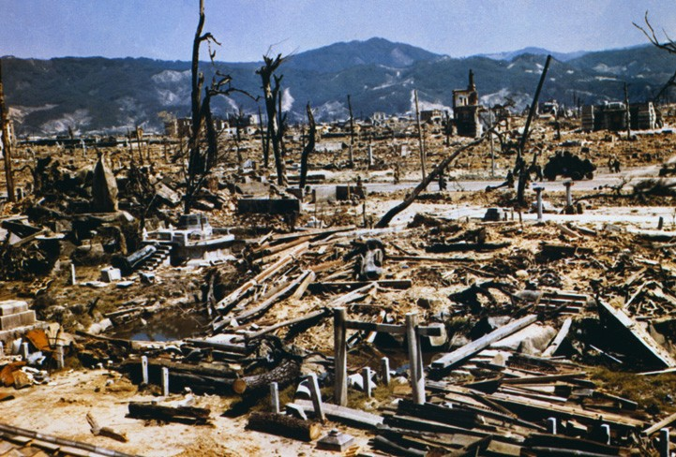
© Bettmann/CORBIS
Caption: Destruction in Hiroshima, 1945.
- Comparing Did Tibbets’s description of the destruction to Hiroshima reflect what the photograph shows? Explain.

NAME DATE CLASS
- Analyzing Primary Sources To what killing was Tibbets referring when he said, “We were determined to stop the killing”? What is ironic about his statement?
- Interpreting Look up the words demonic and malediction. Then explain the meaning of the metaphor in the last sentence of Hiroshi’s recollection.
- Identifying Main Ideas How did the bombings affect Japanese civilians?
- Determining Cause and Effect What impact did the bombing of Hiroshima and Nagasaki have on the course of the war?

