NAME DATE CLASS

Visual Literacy Activity

World War I and the Russian Revolution

Science and Technology: World War I Military Technologies
The new military technologies introduced during World War I, the first truly modern war, changed the very nature of how wars were fought and won. These technologies not only made World War I deadlier than previous wars but also caused psychological damage to soldiers.
Directions: The photographs present some of military technologies that made World War I more devastating than all previous wars. Look closely at the photographs, read the captions, analyze the images, and answer the questions below.

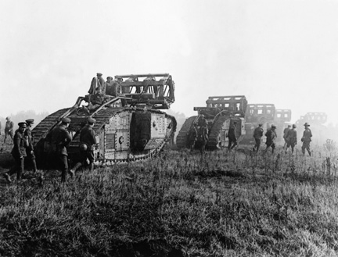
© Hulton-Deutsch Collection/CORBIS
British tanks with trench- crossing equipment advance with troops in support, during trench warfare in France during the First World War.
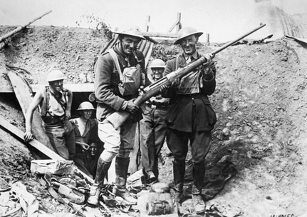
© Bettmann/CORBIS
British soldiers holding a German antitank gun.

Background
World War I was marked by a staggeringly large loss of life. Almost 8.5 million soldiers had died by the end of the war. Millions were killed by weapons never before used in war, such as new kinds of guns and artillery as well as poison gas. World War I also marked the beginning of mechanized war—war fought with motorized vehicles—and aerial warfare.
The British developed the first tanks, which were a response to the challenges of traveling through the trenches. They moved on tracks instead of wheels and could roll through trenches and other impediments, such as barbed wire. Early tanks were slow and clumsy, but their armor repelled most small arms. Changes in how war was conducted prompted innovation: the creation of antitank weapons such as mines, missiles, and large-caliber rifles like the German 88-millimeter antitank gun, which could easily destroy tracks and penetrate tank armor.

NAME DATE CLASS

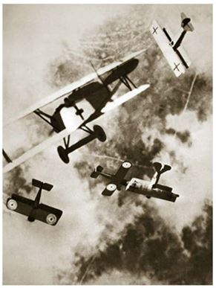
© Stapleton Historical Collection / HIP / The Image Works
Aerial combat takes place on the Western Front during World War I.
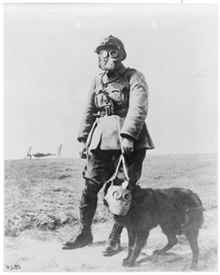
Library of Congress Prints & Photographs Division
A German soldier and his dog wear gas masks.
Aerial warfare first involved pilots shooting at enemy planes with small firearms like pistols, but the practice was very dangerous, as bullets could ricochet off the propeller and kill the pilot. In 1915, the Germans developed a machine gun that could be mounted on a plane; the machine gun was precisely timed to shoot its artillery safely between airplane propeller blades. Armed aerial engagement led to deadly, acrobatic dogfights in the sky as aviators sought to shoot down enemy planes. World War I pilots developed the art of the surprise attack and engaged in phenomenal feats of diving and climbing in the air. Only later in the war were airplanes used for ground attacks, dropping bombs on enemy targets and conducting strafing runs with their mounted machine guns.
Modern chemical warfare began in 1915 when the Germans created a huge cloud of toxic chlorine gas. Later, both sides started using various kinds of chemical gases: choking agents; tear gases, which obscured soldiers’ vision; blistering agents, such as mustard gas, which caused both exterior (eyes and skin) and interior (lungs) burning and bleeding; and blood agents, such as hydrogen cyanide, which choked off oxygen to red blood cells. Tight-fitting gas masks were an essential piece of equipment in the trenches, but they were not equally effective against every chemical agent, and protective overgarments often had to be used as well. As many as one-third of all those who were injured or killed in World War I were victims of chemical warfare.

NAME DATE CLASS

Practicing the Skill
- Explaining Which of these photographs best captures your idea of what World War I combat was really like? Explain.
- Inferring How did trench warfare influence the invention of new weapons and new ways of conducting battle?

Go a Step Further
- Comparing and Contrasting The new military technologies introduced during World War I made that war more devastating than any previous war. These new technologies also caused psychological damage known at the time as “shell shock”—or what we today call “post-traumatic stress disorder”—to troops. Compare and contrast how new technologies and ways of fighting affected soldiers then and now.

